Name

Mathematics Stage 5 Path
General and Point-Gradient Form of a Line

Book 1 | Use various forms of the equation of a straight line | Version: 260314  Feedback:  https://MrDingMaths.com
Contents
Syllabus Content 2
General Form 3
Sketching using Intercepts 5
Finding the Equation given Gradient and a Point 10
Finding the Equation given Two Points 12
Finding the Equation of Parallel and Perpendicular Lines 18

Syllabus Content
MA5-LIN-P-01 describes and applies transformations, the midpoint, gradient/slope and distance formulas, and equations of lines to solve problems
Use various forms of the equation of a straight line
- Rearrange linear equations from gradient–intercept form $\left(y=mx+c\right)$ to general form $(ax+by+c=0)$ and vice versa
- Find the $x$- and $y$-intercepts of a straight line in any form
- Graph the equation of a straight line in any form
- Use the point–gradient form ($y-y_{1}=m\left(x-x_{1}\right)$) or the gradient–intercept form ($y=mx+c$) to find the equation of a line passing through a point $\left(x_{1}, y_{1}\right)$, with a given gradient $m$
- Use the gradient and the point–gradient form to find the equation of a line passing through 2 points
- Find the equation of a line that is parallel or perpendicular to a given line in any form
- Determine and justify whether 2 given lines are parallel or perpendicular

General Form

- General Form of a Line
The general form of a line is:
$$ax+by+c=0$$

Where $a,b,c$are expressed as integers if possible, and $a$ is preferred to be positive.

- Identify General form of a line
✖  $$y=3x+5$$ | ✔  $$3x-y+5=0$$ |  | ✔  $$99x+25y=0$$ |  | ✖  $$-99x+25y=0$$
Identify the lines written in general form:
- $y=2x+3$ |  | - $2x-y+3=0$ |  | - $x-3y+6=0$
- $-x+3y-6=0$ |  | - $0.5x+y-2=0$ |  | - $3x-4y-$ $\frac{1}{5}$ $=0$

- Example Rearrange an equation of a line to general form.
Rearrange $y=3x-7$ to general form.
$$-3x+y+7=0$$
$3x-y-7=0$

- Guided Practice
Rearrange to general form.
- $y=5x-2$  $$5x-y-2=0$$ | - $y=\frac{1}{2}x-3$  $$x-2y-6=0$$
- $y=2x-\frac{3}{5}$  $$10x-5y-3=0$$ | - $y=\frac{x}{4}+\frac{1}{3}$  $$3x-12y+4=0$$

Foundation
- Rearrange to general form $ax+by+c=0$
- $y=x+2$  $$x-y+2=0$$ | - $y=3x-1$  $$3x-y-1=0$$ | - $y=8+5x$  $$5x-y+8=0$$
- $x+2y=3$  $$x+2y-3=0$$ | - $x-2y=6$  $$x-2y-6=0$$ | - $y=8x+2$  $$8x-y+2=0$$
- $y+3=6x$  $$6x-y-3=0$$ | - $2y=x-6$  $$x-2y-6=0$$ | - $y=$ $\frac{3x}{5}$ $+2$  $$3x-5y+10=0$$

- Rearrange to general form $ax+by+c=0$
$$y=\frac{x}{3}+\frac{1}{4}$$  $$4x-12y+3=0$$ | $$y=-\frac{5x}{8}+\frac{3}{2}$$  $$5x+8y-12=0$$ | $$y=\frac{3x}{4}-\frac{2}{5}$$  $$15x-20y-8=0$$
$$y=-\frac{x}{2}-\frac{3}{4}$$  $$2x+4y+3=0$$ | $$y=\frac{3x}{2}+\frac{2}{5}$$  $$15x-10y+4=0$$ | $$y=-\frac{9x}{10}-\frac{7}{15}$$  $$27x+30y+14=0$$

Sketching using Intercepts

- Finding the $x$ and $y$ intercepts
$y$ intercept: substitute $x=0$ and solve.
$x$ intercept: substitute $y=0$ and solve.

- Example Identify $x$ and $y$ intercept from the equation
Find the $x$ and $y$ intercepts of  $$y=4x+2$$ | Find the $x$ and $y$ intercepts of  $$x+2y-6=0$$
  $y$-int: $x=0$  $$y=4\left(0\right)+2 \\ y=2$$  $y$-int is at $(0,2)$ | $x$-int: $y=0$  $$0=4x+2 \\ -2=4x \\ -\frac{2}{4}=x \\ -0.5=x$$  $x$-int is at $(-0.5 ,0)$
  $y$-int: $x=0$  $$0+2y-6=0 \\ 2y=6 \\ y=3$$  $y$-int is at $(0,3)$ | $x$-int: $y=0$  $$x+2\left(0\right)-6=0 \\ x-6=0 \\ x=6$$$x$-int is at $(6 ,0)$

- Guided Practice
Find the $x$ and $y$ intercepts of these lines.
- $y=2x-8$  $x$-int: $(4,0)$, $y$-int: $\left(0,-8\right)$ | - $x-y=7$  $x$-int: $\left(7,0\right)$, $y$-int: $\left(0,-7\right)$
  $y int:$ $x=0$  $y=2\left(0\right)-8$ | $x int:$ $y=0$  $0=2x-8$
  $y int:$ $x=0$ | $x int:$ $y=0$
- $-3x-2y=6$  $x$-int: $\left(-2,0\right)$, $y$-int: $\left(0,-3\right)$ | - $4x+4y=7$  $x$-int: $\left(\frac{7}{4},0\right)$, $y$-int: $\left(0,\frac{7}{4}\right)$

- Sketching lines using the intercepts
- Find the $y$ intercept ($x=0$)
- Find the $x$ intercept ($y=0$)
- Connect the $x$ and $y$ intercept and extend the straight line.

- Example Sketch graphs from the equation by finding the intercepts
Sketch $x+2y+6=0$ | 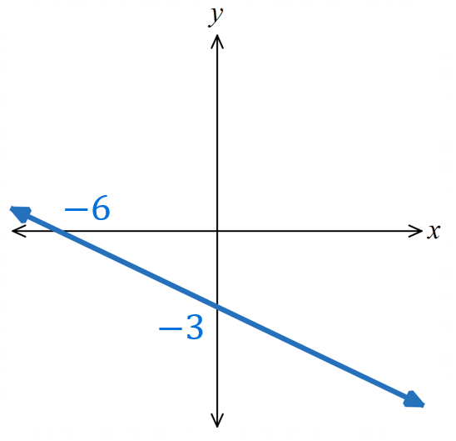  3.
  1. $y$-int: $x=0$  $2y+6=0$  $2y=-6$  $y=-3$ | 2. $x$-int: $y=0$  $$x+6=0$$  $x=-6$

- Guided Practice
Sketch by finding the intercepts:
- $3y=4x-6$  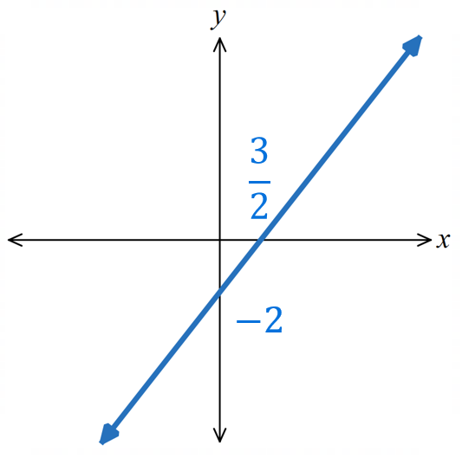 | - $4x-2y=14$  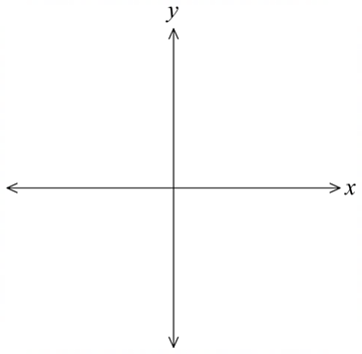  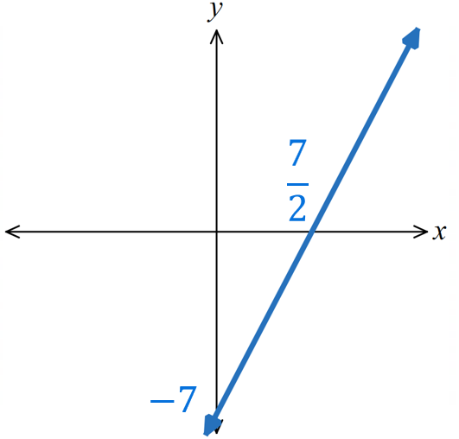

Foundation
- Determine the $x$ and $y$ intercepts for these lines.
- $y=x+1$  x-int: (−1, 0), y-int: (0, 1) | - $y=\frac{1}{2}x-3$  x-int: (6, 0), y-int: (0, −3)
  $y int:$ $x=0$ | $x int:$ $y=0$
- $y=x$  x-int: (0, 0), y-int: (0, 0) | - $y-3x=0$  x-int: (0, 0), y-int: (0, 0)
- $x+y-1=0$  x-int: (1, 0), y-int: (0, 1) | - $x-3y-3=0$  x-int: (3, 0), y-int: (0, −1)
- $2x-3y-12=0$  x-int: (6, 0), y-int: (0, −4) | - $5x+2y-10=0$  x-int: (2, 0), y-int: (0, 5)

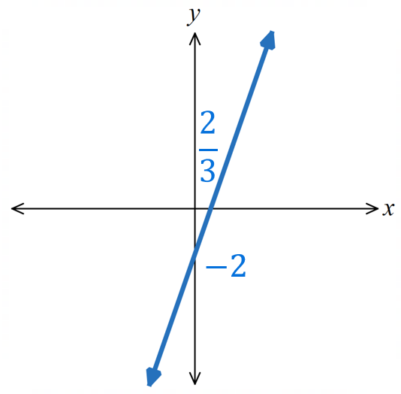
- Follow these steps for the equation $y=3x-2$
  - Find the $y$-intercept by substituting $x=0$.

  - Find the $x$-intercept by substituting $y=0$ then solving.

  - Sketch the graph on the axis.

- Follow these steps for the equation $x+2y-4=0$
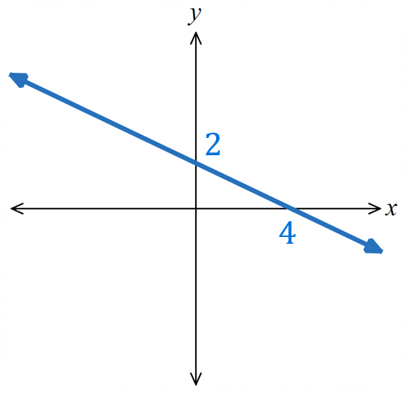
  - Find the $y$-intercept by substituting $x=0$.

  - Find the $x$-intercept by substituting $y=0$ then solving.

  - Sketch the graph on the axis.

Development
- Sketch these lines. Show the $y$-intercept and $x$-intercept.
- $y=2x-4$  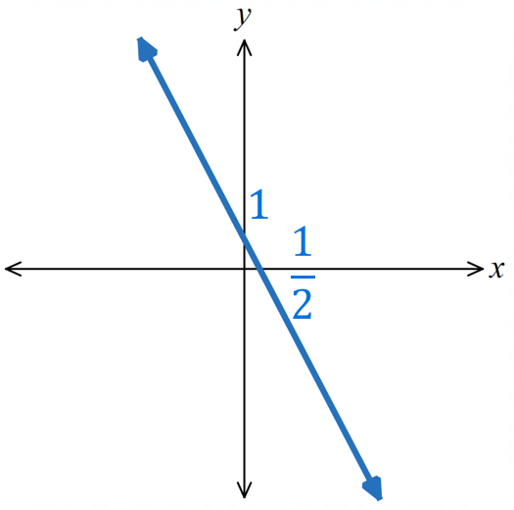  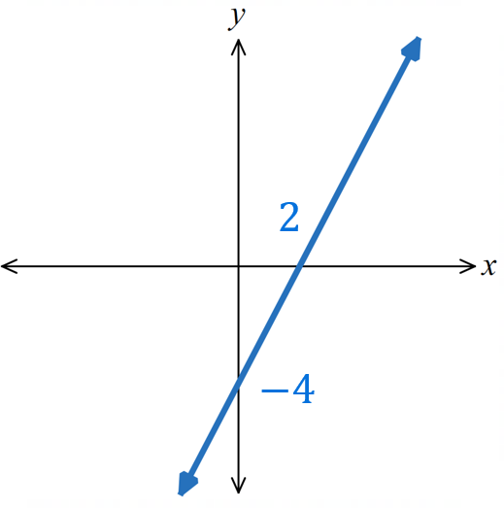 | - $y=-2x+1$ | - $y=5x-3$  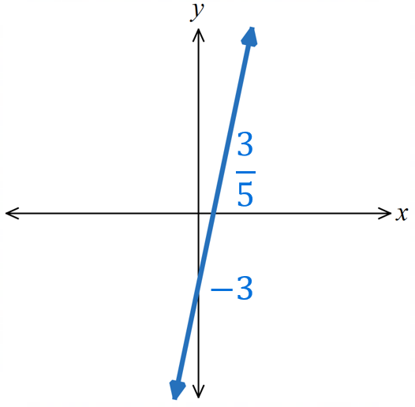
- $y=-\frac{3}{2}x+1$  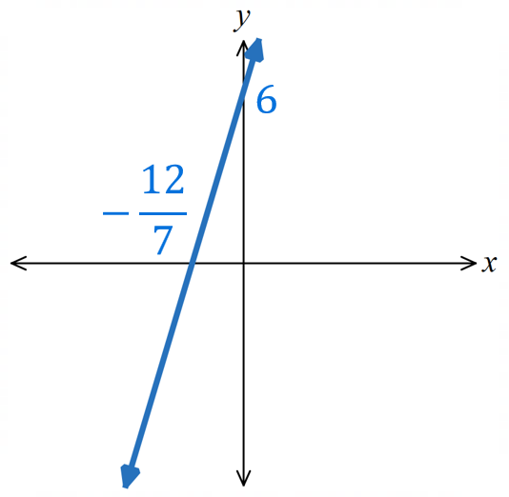  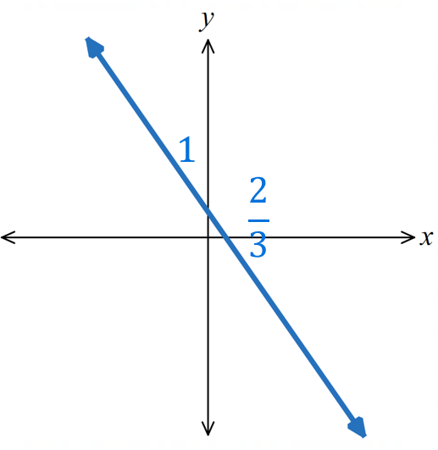 | - $y=\frac{7}{2}x+6$ | - $y=3+\frac{2}{3}x$  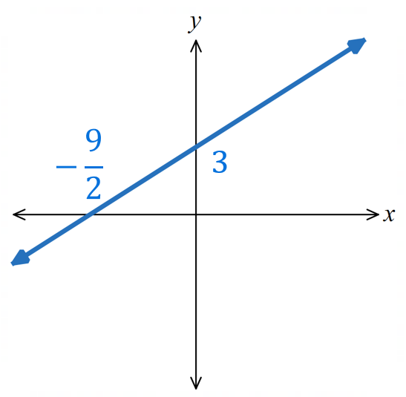
- $y=\frac{1}{2}x-2.5$  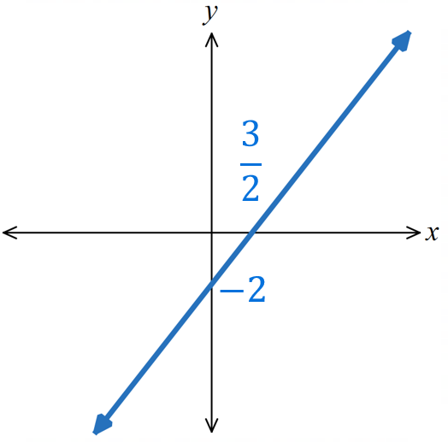  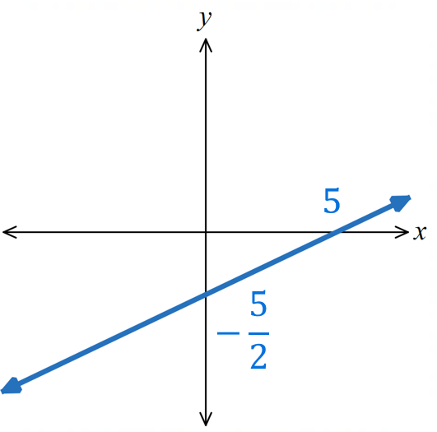 | - $y=\frac{4x}{3}-2$ | - $y=4-2x$  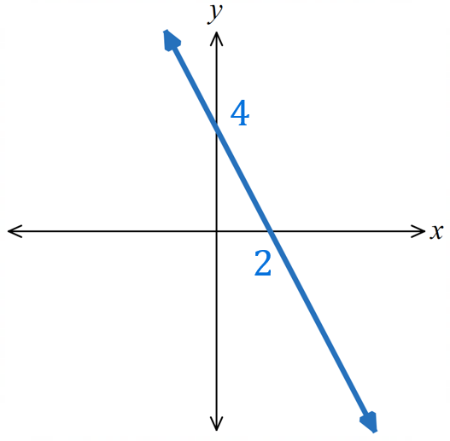
- Sketch these graphs by finding the $x$- and $y$-intercepts.
- $3x+y=12$  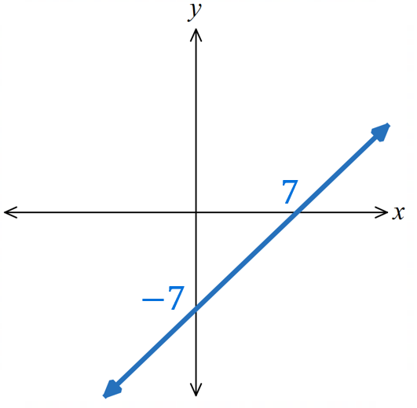  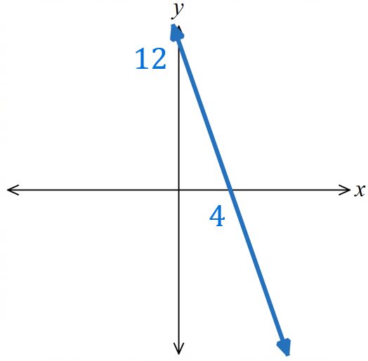 | - $x-y=7$ | - $4x-3y=9$  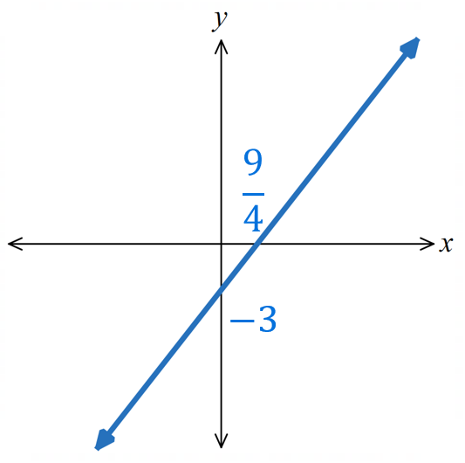
- $10x+2y=5$  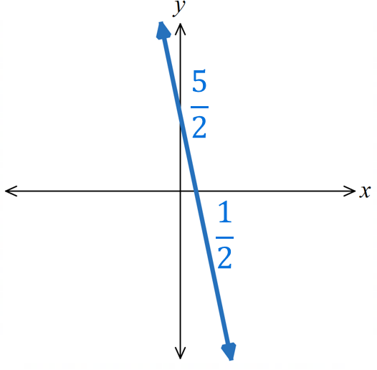 | - $2x-y+2=0$  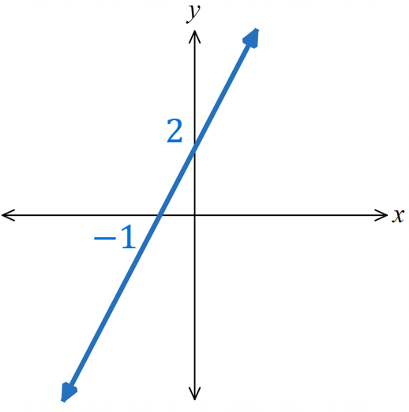 | - $3x+2y=12$  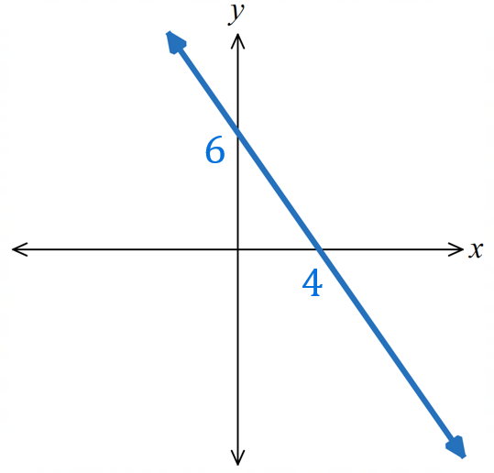
- $5y-2x=12$  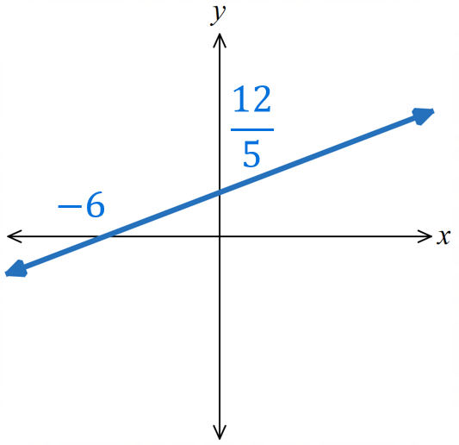 | - $4y-3x=24$  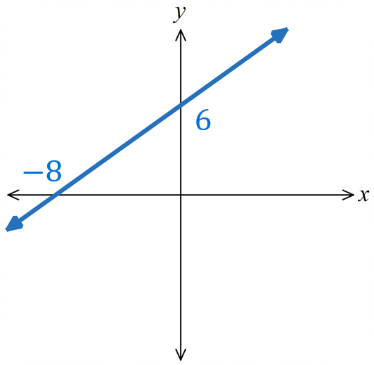 | - $-5x+2y+15=0$  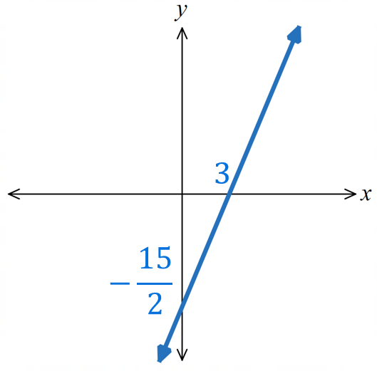

Finding the Equation given Gradient and a Point

- Point-Gradient Formula
The point-gradient formula of a line relates the gradient $m$ and any point on the line $\left(x_{1},y_{1}\right)$

gradient

$$y-y_{1}=m\left(x-x_{1}\right)$$
$\begin{matrix}y coordinate \\ of a point\end{matrix}$ $\begin{matrix}x coordinate \\ of a point\end{matrix}$

- Example Find equation of a line given gradient and a point
Find the equation of the line with  gradient $3$ passing through $(6,4)$.  $m$ $x_{1} y_{1}$  $$y-y_{1}=m(x-x_{1}) \\ y-4=3(x-6) \\ y-4=3x-18 \\ y=3x-14$$ | Find the equation of the line with  gradient $-4$ and $x$ intercept 1.  $m$ $\left(x_{1} y_{1}\right)=\left(1,0\right)$  $$y-y_{1}=m(x-x_{1}) \\ y-0=-4\left(x-1\right) \\ y=-4x+4$$

- Guided Practice
Find the equation of the line, in gradient-intercept form, with:
- Gradient 4 and passes through $(-1,2)$  $$y=4x+6$$ | - Gradient 3 and passes through $(-3,5)$  $$y=3x+14$$
- Gradient $\frac{1}{3}$ and passes through $(9,2)$  $$y=\frac{x}{3}-1$$ | - Gradient $-3$ passes through $(8,-5)$  $$y=-3x+\frac{13}{3}$$

Foundation
- Use $y-y_{1}=m(x-x_{1})$ to find the equation of these lines in gradient-intercept form.
- $(3,2)$ and $m=4$  $$y-y_{1}=m\left(x-x_{1}\right) \\ y-2=4\left(x-3\right)$$  $$y=4x-10$$ | - $(4,-1)$ and $m=-1$  $$y=-x+3$$ | - $(-7,2)$ and $m=\frac{1}{2}$  $$y=\frac{x}{2}+\frac{11}{2}$$
- $(2,5)$ and $m=2$  $$y=2x+1$$ | - $(-6,4)$ and $m=-1$  $$y=-x-2$$ | - $(3,-8)$ and $m=4$  $$y=4x-20$$

- Find the equation of the line:
- through (1,1) with gradient 2  $$y = 2x - 1$$ | - with gradient −1  through (3, 1)  $$y = -x + 4$$ | - through (0,0) with gradient −5  $$y = -5x$$
- through (−1,3) with gradient $-$ $\frac{1}{3}$  $$y = -\frac{x}{3}+\frac{8}{3}$$ | - with gradient $-\frac{4}{5}$  through (3, −4).  $$y = -\frac{4x}{5}-\frac{8}{5}$$ | - through $(-5,3)$ with gradient $-\frac{3}{5}$  $$y = -\frac{3x}{5}$$
- A line passes through the $y$-axis at (0, 6) and has a gradient of $\frac{5}{7}$. What is its equation?

$$y=\frac{5x}{7}+6$$
- Find the equation of a line with a gradient of $-4$ and an $x$-intercept of 5.

$$y=-4x+20$$

Finding the Equation given Two Points

- Finding Equation of a Line given Two Points
- Calculate gradient using the formula: $m=$ $\frac{y_{2}-y_{1}}{x_{2}-x_{1}}$
- Substitute into point-gradient form. $y-y_{1}=m(x-x_{1})$
- Rearrange to $y=mx+c$.

- Example Find equation of a line given two points
Find the equation of the line, in gradient-intercept form, passing through $(1, 5)$ and $(4, -1)$
1. $m=$ $\frac{y_{2}-y_{1}}{x_{2}-x_{1}}=$ $\frac{-1-5}{4-1}$ $=-2$2. Sub $m=-2$ and (1,5)
$$y-y_{1}=m(x-x_{1}) \\ y-5=-2\left(x-1\right)$$3. $y-5=-2x+2$ $y=-2x+7$

- Guided Practice
Find the equation of the line, in gradient-intercept form, passing through:
- $(2,7)$ and $(-1.5,0)$  1. $m=$ $\frac{y_{2}-y_{1}}{x_{2}-x_{1}}$  2. $y-y_{1}=m(x-x_{1})$  3.  $$y=2x+3$$ | - $(1,7)$ and $(3,-1)$  $$y=-4x+11$$
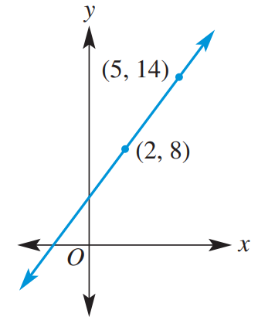  $$y=2x+4$$ | 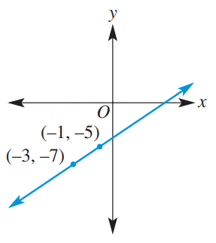  $$y=x-4$$

Foundation
- Determine the equation of the line that pass through these two points.
- $(4,2)$ and $(12,4)$  $$y =\frac{x}{4}+ 1$$ | - $(1,4)$ and $(3,8)$  $$y = 2x + 2$$ | - $(-1,3$) and $(2,0)$  $$y = -x + 2$$
- $(7,3)$ and $(10,6)$  $$y = x - 4$$ | - $(2,-2)$ and $(-1,6)$  $$y = -\frac{8x}{3}+\frac{10}{3}$$ | - $(-10,2$) and $(1,-4)$  $$y = -\frac{6x}{11}-\frac{38}{11}$$

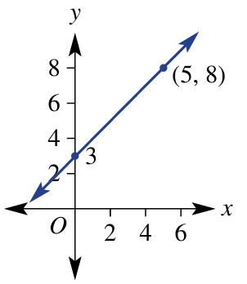
- Find the equation of these lines using an appropriate method.
(Hint: some of these graphs already give you the $y$-intercept, so you only need the gradient)
$$y=x+3$$ | 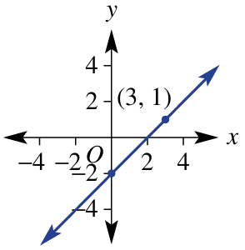  $$y=x-2$$ | 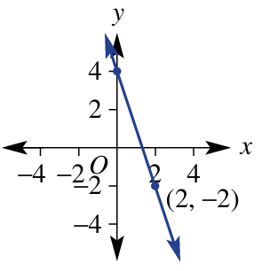  $$y=-3x+4$$
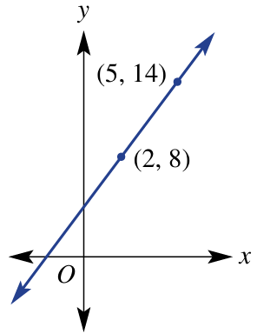  $$y=2x+4$$ | 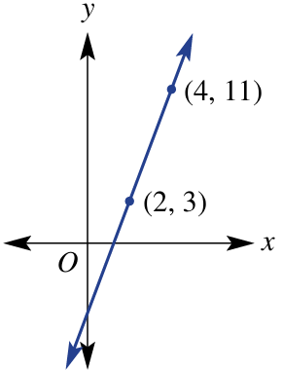  $$y=4x-5$$ | 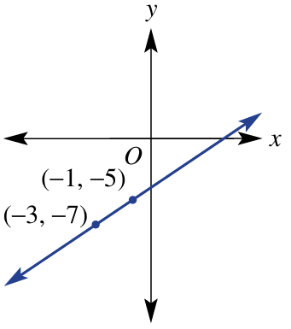  $$y=x-4$$
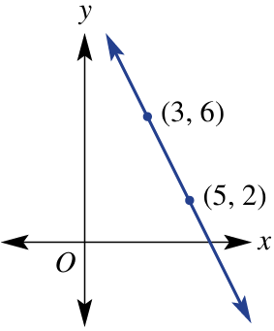  $$y=-2x+12$$ | 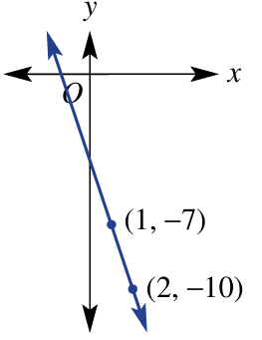  $$y=-3x-4$$ | 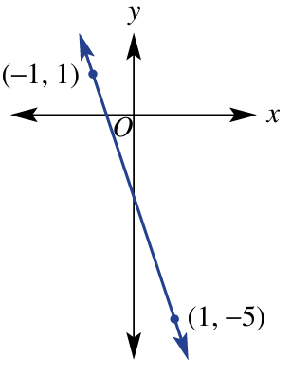  $$y=-3x-2$$

- Consider the points P(4, 7) and Q(6, −1).
- Calculate the length of PQ.  $$\sqrt{68}$$ | - Find the midpoint of the PQ.  (5, 3)
- What is the gradient of PQ?  $$-4$$ | - Find the equation of the line passing through P and Q.  $$y = -4x + 23$$

- A line with gradient $\frac{2}{3}$ passes through the midpoint of $(5,6)$and $(1,10)$.
Find the equation of the line.

Midpoint: (3, 8)
$$y =\frac{2x}{3}+ 6$$
- A line with gradient $-\frac{3}{5}$ passes through the midpoint of $(-8,2)$and $(-2,20)$.
Find the equation of the line.

Midpoint: $\left(-5,11\right)$
$$y = -\frac{3x}{5}+ 8$$

Development
- Determine the equation of a line with gradient $-4$ and passes through $\left(3,-10\right)$.
Method 1: Substitute into $y-y_{1}=m\left(x-x_{1}\right)$  $$y + 10 = -4(x - 3)$$  $$y = -4x + 2$$ | Method 2: Substitute into $y=mx+c$ and  solve for $c$  $$-10 = -4(3) + c$$  $$c = 2$$  $$y = -4x + 2$$

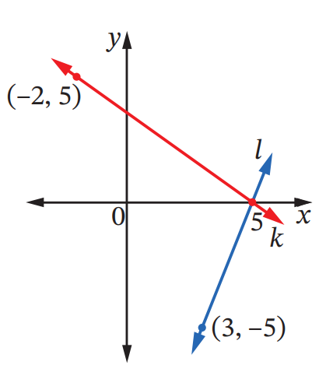
- The diagram shows line $k$ and line $l$. Find:
  - The equation of line $l$ in general form.

$$5x-2y-25=0$$
  - The equation of line $k$ in general form.

$$5x+7y-25=0$$
  - $w$ if the point $(7,w)$ lies on $l$.

$$w=5$$
  - $t$ if the point $\left(t,11\right)$ lies on $k$.

$$t=-\frac{52}{5}$$

- A line with gradient 4 passes through $(1, 5)$ and $(-2, k).$ Find the value of $k$.  $$k = -7$$ | - Find the value of $a$ if $2x+5y-6=0$ passes through $\left(a, -2\right)$.  $$a = 8$$
- Find the value of $a$ if $ax-8y+3=0$ passes through $\left(-7, 3\right)$.  $$a = -3$$ | - Find the value(s) of $a$ if $ax+y=6$ passes through $(a,5a)$  $a = -6$ or $a = 1$

Mastery
- This is the intercept form of a straight line.
$$\frac{x}{a}+\frac{y}{b}=1$$
  - Find the $x$ and $y$-intercepts of this line and hence explain why it’s called the intercept from of a straight line.

When $y = 0: x = a$ ($x$-intercept is $a)$
When $x = 0: y = b$ ($y$-intercept is $b)$
It's called the intercept form because a and b directly give the $x$ and $y$-intercepts.
  - Use the intercept form to find the equation of a line with $x$-intercept at $-2$ and
$y$-intercept at 3.

$$\frac{x}{-2}+\frac{y}{3}= 1$$
$$3x - 2y = -6$$
  - Use this knowledge to quickly sketch these lines without any calculations.
$$\frac{x}{6}-\frac{y}{3}=1$$  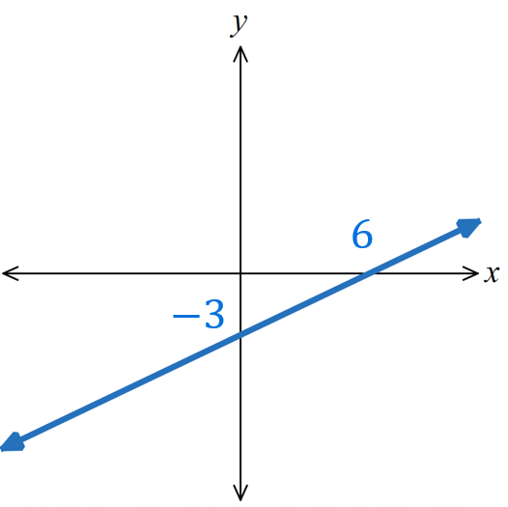 | $$-x+\frac{y}{2}=1$$  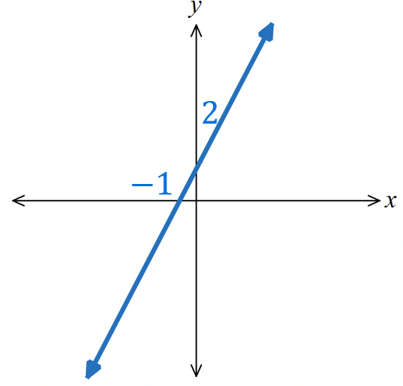 | $$\frac{x}{2}+\frac{y}{5}=1$$  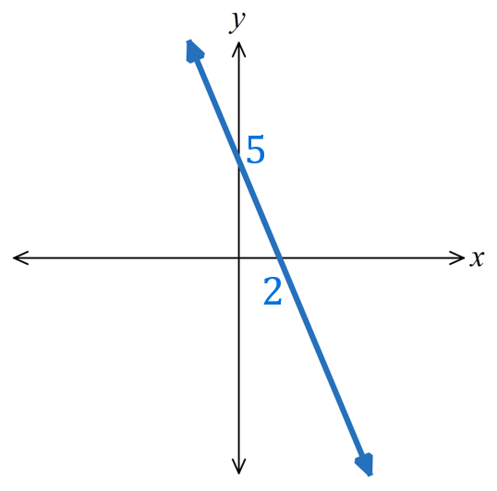  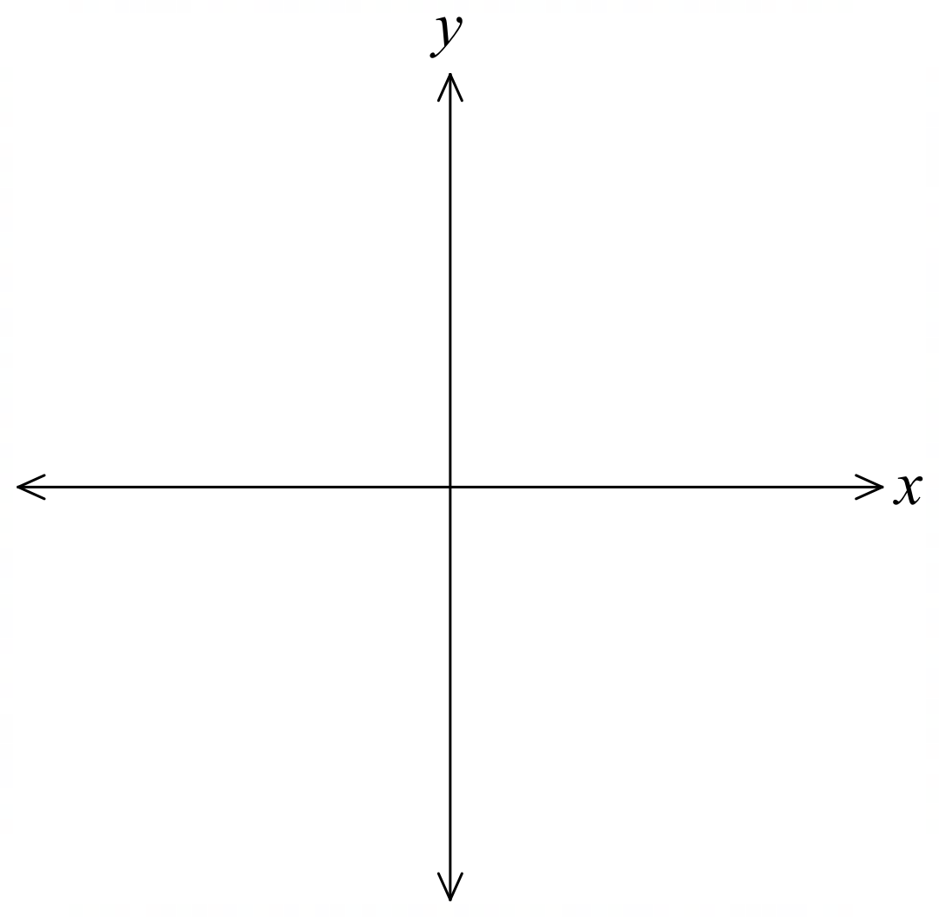

- Another form of a line is the two-point form that states the equation of a line that passes through any two points $\left(x_{1}y_{1}\right)$ and $\left(x_{2},y_{2}\right)$. We will derive it in this section.
  - What is the expression for the gradient between the two points $\left(x_{1}y_{1}\right)$ and $\left(x_{2},y_{2}\right)$?

$$m =\frac{y_{2}-y_{1}}{x_{2}-x_{1}}$$
  - Use the formula $y-y_{1}=m(x-x_{1})$ and the expression in part a to show that the two-point form of a line is $\frac{y-y_{1}}{x-x_{1}}=\frac{y_{2}-y_{1}}{x_{2}-x_{1}}$

$$y-y_{1}=\frac{y_{2}-y_{1}}{x_{2}-x_{1}}\left(x-x_{1}\right)$$
$$\frac{y-y_{1}}{x-x_{1}}=\frac{y_{2}-y_{1}}{x_{2}-x_{1}}$$
  - Use the two-point form to find the equation of a line passing through $(7,3)$ and $(10,6)$. Answer in gradient-intercept form. Check your answer using DESMOS.

$$\frac{y-3}{x-7}=\frac{6-3}{10-7}$$
$$\frac{y-3}{x-7}= 1$$
$$y - 3 = x - 7$$
$$y = x - 4$$
  - Find the equation of a line passing through $(-1,10)$ and $(10,-17.5)$.
Answer in gradient-intercept form. Check your answer using DESMOS.

$$\frac{y-10}{x+1}=\frac{-17.5-10}{10+1}$$
$$\frac{y-10}{x+1}= -2.5$$
$$y - 10 = -2.5\left(x + 1\right)$$
$$y = -2.5x + 7.5$$

Finding the Equation of Parallel and Perpendicular Lines

- Review
- Recall parallel and perpendicular gradients
- Gradient parallel to $m=3$ | - Gradient parallel to $m=$ $\frac{2}{3}$
- Gradient perpendicular to $m=$ $\frac{2}{3}$ | - Gradient perpendicular to $m=-5$
- Gradient parallel to $y=$ $\frac{x}{7}$ $+3$ | - Gradient perpendicular to $y=$ $\frac{3x}{2}$ $-4$

- Find equation of parallel/vertical line, given $y$-intercept of new line
- Find the equation of the line parallel to $y=5x-2$ passing through $\left(0,1\right)$ | - Find the equation of the line perpendicular to $y=$ $\frac{3x}{7}$ $-2$ passing through $\left(0,-5\right)$

- Find equation of line given gradient and a point
- Find the equation of the line with gradient 3 passing through $(4,5)$ | - Find the equation of the line with gradient $-$ $\frac{3}{5}$ passing through $(2,-5)$

- Finding the Equation of a Parallel and Perpendicular Line
Gradient of a Parallel Line  $$m_{par}=m_{original}$$ | Gradient of Perpendicular Line  $$m_{perp}=-\frac{1}{m_{original}}$$
- Determine gradient $m_{new}$ of the parallel/perpendicular line.
- Write the equation $y-y_{1}=m_{new}(x-x_{1})$
- Substitute new gradient and given point into the formula.
- Rearrange to $y=mx+c$

- Example Find the equation of a parallel/perpendicular line
Find the equation of a line, in gradient-intercept form, that is:
Parallel to $y=-2x-7$ through $(1,9)$  1. $m_{new}=-2$  2. $y-y_{1}=m_{new}\left(x-x_{1}\right)$3. $y-9=-2\left(x-1\right)$4. $y-9=-2x+2$ $y=-2x+11$ | Perpendicular to $y=\frac{3}{4}x-1$ through $(3,-2)$  1. $m_{new}=-$ $\frac{4}{3}$  2. $y-y_{1}=m_{new}\left(x-x_{1}\right)$  3. $y-\left(-2\right)=$ $-$ $\frac{4}{3}$ $\left(x-3\right)$  4. $y+2=-$ $\frac{4x}{3}$ $+4$  $y=-$ $\frac{4x}{3}$ $+2$

- Guided Practice
Find the equation of the line, in gradient-intercept form that is:
- Parallel to $y=x+3$ and  passes through $(1, 5)$  1. $m_{new}=$ …………  2. $y-y_{1}=m_{new}\left(x-x_{1}\right)$  3.  4.  $$y=x+4$$ | - Parallel to $y =\frac{2}{3}x+1$ and  passes through $(3, -4)$  1. $m_{new}=$ …………  2. $y-y_{1}=m_{new}\left(x-x_{1}\right)$  3.  4.  $$y=\frac{2x}{3}-6$$
- Perpendicular to $y=2x+3$ and  passes through $(2, 5)$  $$y=-\frac{x}{2}+6$$ | - Perpendicular to $y=-4x+1$ and passes through $(-4, -3)$  $$y=\frac{x}{4}-2$$

Foundation
- Find the gradient of a line that is parallel to each line.
- $y=4x+6$  4 | - $y=-7x-1$  $$-7$$ | - $y=-\frac{3}{4}x+2$  $$-\frac{3}{4}$$ | - $y=\frac{8x}{7}-\frac{1}{2}$  $$\frac{8}{7}$$
- Find the gradient of a line that is perpendicular to each line.
- $y=3x-1$  $$-\frac{1}{3}$$ | - $y=-2x+6$  $$\frac{1}{2}$$ | - $y=\frac{7}{8}x-\frac{2}{3}$  $$-\frac{8}{7}$$ | - $y=\frac{-4x}{9}-\frac{4}{7}$  $$\frac{9}{4}$$
- Decide if these pairs of lines are parallel, perpendicular, or neither.
- $y=3x-1$  $y=3x+7$  parallel | - $y=\frac{1}{2}x-6$  $y=\frac{x}{2}-4$  parallel | - $y=-\frac{2}{3}x+1$  $y=\frac{2}{3}x-3$  neither
- $y=-8x+4$  $y=\frac{1}{8}x-2$  perpendicular | - $x-y=4$  $y=-x+\frac{1}{2}$  perpendicular | - $3x-y=2$  $x+3y=5$  perpendicular

- Find the equation of:
- the line through (2, 5) and parallel to  $$y=2x+5$$  $$y=2x+1$$ | - the line through (2, 5) and perpendicular to $y=2x+5$  $$y=-\frac{x}{2}+6$$
- the line through (−7, 6) and parallel to $y=\frac{3x}{7}-8$  $$y-\frac{3x}{7}+9$$ | - the line through (−4, 0) and perpendicular to y = $-\frac{2}{5}x$  $$y=\frac{5x}{2}+10$$

- Write down the line that is parallel to the given lines and passes through the given point.
Parallel to | Goes through | Answer
$$y=3x+2$$ | $$(0,7)$$ | $$y=3x+7$$
$$y=3x+2$$ | $$(3,0)$$ | $$y=3x-9$$
$$y=3x+2$$ | $$(3,7)$$ | $$y=3x-2$$
$$y=3x+10$$ | $$(3,7)$$ | $$y=3x-2$$
$$y=2x-2$$ | $$(3,7)$$ | $$y=2x+1$$
$$y=2x-2$$ | $$(-3,7)$$ | $$y=2x+13$$
$$y=2x-2$$ | $$(0,0)$$ | $$y=2x$$
$$y=-3$$ | $$(8,11)$$ | $$y=11$$

- Write down the line that is perpendicular to the given lines and passes through the given point.
Perpendicular to | Goes through | Answer
$$y=-x+2$$ | $$(0,7)$$ | $$y=x+7$$
$$y=2x+2$$ | $$(0,7)$$ | $$y=-\frac{x}{2}+7$$
$$y=2x+2$$ | $$(12,7)$$ | $$y=-\frac{x}{2}+13$$
$$y=3x+2$$ | $$(12,7)$$ | $$y=-\frac{x}{3}+11$$
$$y=3x+2$$ | $$(10,7)$$ | $$y=-\frac{x}{3}+\frac{31}{3}$$
$$y=3x+2$$ | $$(-12,7)$$ | $$y=-\frac{x}{3}+3$$
$$y=2x+2$$ | $$(0,0)$$ | $$y=-\frac{x}{2}$$
$$x=7$$ | $$(0,3)$$ | $$y=3$$

Development
- Find the equation of the line that is:
- Perpendicular to $y=\frac{2x-1}{3}$  passing through $(0,5)$  $$y=-\frac{3x}{2}+5$$ | - Parallel to $y=\frac{3-5x}{7}$  passing through $(1,7)$  $$y=-\frac{5x}{7}+\frac{54}{7}$$
- Parallel to $3y-2x=3$  passing through $(-2,4)$  $$y=\frac{2x}{3}+\frac{16}{3}$$ | - Perpendicular to $7x-y=-1$  passing through $(-3,-1)$  $$y=-\frac{x}{7}-\frac{10}{7}$$
- Parallel to $y=-$ $\frac{3}{7}$  passing through $\left(\frac{2}{3},\frac{1}{2}\right)$  $$y=\frac{1}{2}$$ | - Perpendicular to $3x+4y-3=0$passing through $\left(-2, 1\right).$  $$y=\frac{4x}{3}+\frac{11}{3}$$
- parallel to the $x$-axis  passing through $(-2,6)$.  $$y=6$$ | - parallel to the $y$-axis  passing through $(3, 5)$.  $$x=3$$

Mastery
- Find the value of $a$ if:
- $y=\frac{a}{7}x+b$ is parallel to $y=2x-4$  $$\frac{a}{7}= 2$$  $$a = 14$$ | - $y=\frac{2a+1}{3}x+b$ is parallel to $y=-x-3$  $$\frac{2a+1}{3}= -1$$  $$2a + 1 = -3$$  $$a = -2$$
- $y=\left(\frac{1-a}{2}\right)x+b$ is perpendicular to  $y=\frac{1}{2}x-\frac{3}{5}$  $$\left(\frac{1-a}{2}\right)\left(\frac{1}{2}\right)= -1$$  $$\frac{1-a}{4}= -1$$  $$1 - a = -4$$  $$a = 5$$ | - $ay=3x+b$ is perpendicular to  $y=-\frac{3}{7}x-1$  $$y =\frac{3}{a}x +\frac{b}{a}$$  $$\left(\frac{3}{a}\right)\left(-\frac{3}{7}\right)= -1$$  $$-\frac{9}{7a}= -1$$  $$9 = 7a$$  $$a =\frac{9}{7}$$
Explain why your answers above don’t depend on the value of $b$.

Parallel and perpendicular depends only on the gradient.
- The line $3x-8y+10=0$ and another line intersect at right angles at the point $\left(10, 5\right)$.
Find the equation of the other line.
$$Perpendicular gradient: -\frac{8}{3}$$
$$y - 5 = -\frac{8}{3}\left(x - 10\right)$$
$$3(y - 5) = -8\left(x - 10\right)$$
$$3y - 15 = -8x + 80$$
$$8x + 3y = 95$$
$$y =\frac{-8x + 95}{3}$$
- In this question, you will find the perpendicular bisector of an interval.
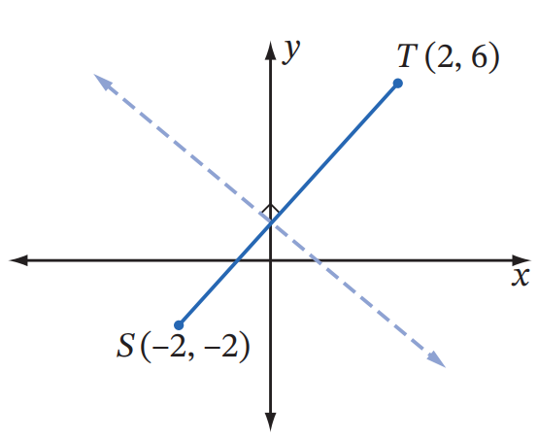
  - Find the gradient of interval $ST$

$m=2$
  - Find the midpoint of $ST$

$M\left(0,2\right)$
  - The dotted line is perpendicular to $ST$ and
passes through its midpoint. What is its gradient?
$$-\frac{1}{2}$$
  - Find the equation of the dotted line.
Answer in gradient-intercept form $y=mx+c$.

$$y=-\frac{1}{2}x+2$$

  - Find the equation of the perpendicular bisector of the line segment joining $\left(1,1\right)$ with $\left(3,5\right)$ in general form.
Midpoint is $\left(2,3\right)$
Gradient is 2
Perp gradient $-$ $\frac{1}{2}$
$$x+2y-8=0$$
  - Find where this bisector cuts the $x$-axis.
$$\left(8,0\right)$$
- The line $ax+by+1=0$ is perpendicular to $4x+3y=7$ and passes through $\left(9, 7\right).$
Find the values of $a$ and $b$.
Gradient of original line: $-$ $\frac{4}{3}$
Perp gradient: $\frac{3}{4}$
$$y-7=\frac{3}{4}\left(x-9\right)$$
$$4y-28=3x-27$$
$$3x-4y-1=0$$
$$a=3, b=-4$$
- The interval $PQ$ has gradient −3. A second line passes through $A\left(-2, 4\right)$ and $B\left(1, k\right)$.
  - Find $k$ if $AB$ is parallel to $PQ$.
$$m_{PQ}= -3$$
$$For AB parallel to PQ:\frac{k-4}{1-\left(-2\right)}= -3$$
$$\frac{k-4}{3}= -3$$
$$k = -5$$
  - Find $k$ if $AB$ is perpendicular to $PQ$.
$$For AB perpendicular to PQ:\frac{k-4}{3}=\frac{1}{3}$$
$$k - 4 = 1$$
$$k = 5$$
- The line $l$ with the equation $x-2y+4=0$ passes through the point $A\left(8,6\right)$ and intersects the
$x$-axis at $B$ as shown on the diagram below.
The line through $A$ and perpendicular to $l$ intersects the $x$-axis at $C$.
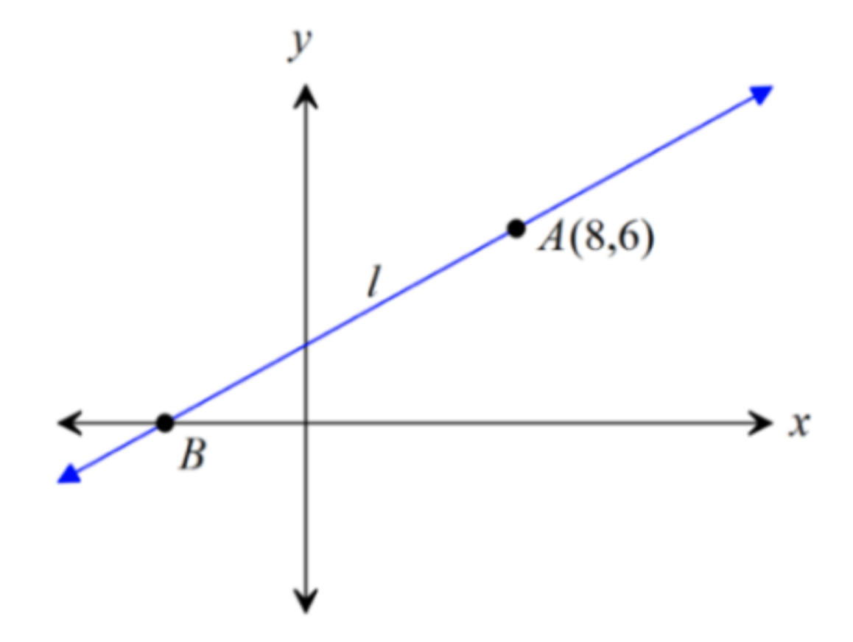
  - Find the equation of $AC$ in general form.

$Gradient of l from x - 2y + 4 = 0 is \frac{1}{2}$
$$Perpendicular gradient: -2$$
$$Through A\left(8,6\right): y - 6 = -2\left(x - 8\right)$$
$$y - 6 = -2x + 16$$
$$2x + y - 22 = 0$$
  - Find the coordinates of $C$.

Let $y=0$
$$\left(11,0\right)$$
- The points $A$ and $C$ lie on the $y$-axis and the point $B$ lies on the $x$-axis.
The line $AB$ has equation $5x-3y=15$.
The line $BC$ is perpendicular to $AB.$
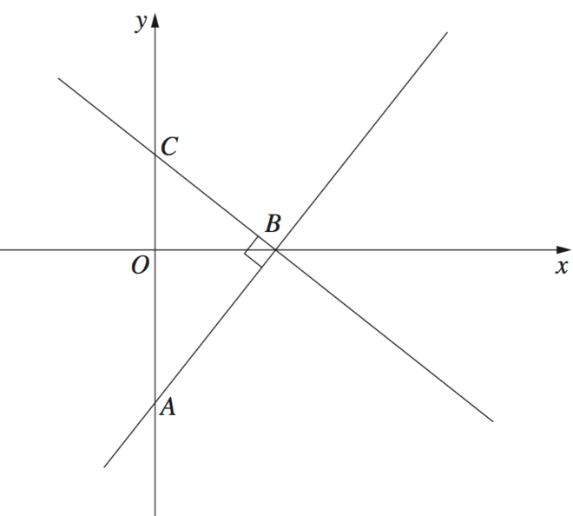
  - Find the coordinates of $B$.

$Line AB: 5x - 3y = 15$
$$On x axis \left(y = 0\right): 5x = 15, x = 3$$
$$B = (3, 0)$$
  - Find the equation of the line $BC$ in general form.
$$Gradient of AB:\frac{5}{3}$$
$$Perpendicular gradient: -\frac{3}{5}$$
$$Through B(3,0): y - 0 = -\frac{3}{5}\left(x - 3\right)$$
$$5y = -3x + 9$$
$$3x + 5y - 9 = 0$$
- Line $A$ has equation $2x+ky=5$.
Line $B$ passes through the points $\left(1,5\right)$ and $\left(4+k, 6\right)$.
Find the value of $k$ if the line $A$ and $B$ do not intersect.

$$Line A: 2x + ky = 5, gradient -\frac{2}{k}$$
$$Line B through \left(1,5\right) and \left(4+k, 6\right): gradient =\frac{6-5}{4+k-1}=\frac{1}{3+k}$$
$$For no intersection \left(parallel\right): -\frac{2}{k}=\frac{1}{3+k}$$
$$-2(3+k) = k$$
$$-6 - 2k = k$$
$$k = -2$$
- Given the points $X\left(-1, 0\right), Y\left(1, a\right) and Z\left(a, 2\right),$find $a$ if $∠YXZ = 90°$.

$$XY⊥XZ, so m_{XY}×m_{XZ}=-1$$
$$m_{XY}=\frac{a-0}{1-\left(-1\right)}=\frac{a}{2}$$
$$m_{XZ}=\frac{2-0}{a-\left(-1\right)}=\frac{2}{a+1}$$
$$m_{XY}× m_{XZ}= -1$$
$$\frac{a}{a+1}= -1$$
$$a = -a - 1$$
$$a = -\frac{1}{2}$$
- For the four points $P\left(k, 1\right), Q\left(-2, -3\right), R\left(2, 3\right) and S(1, k),$ it is known that $PQ$ is parallel to $RS$.
Find the possible values of $k$.
$$m_{PQ}=\frac{-3-1}{-2-k}= -\frac{4}{-2-k}=\frac{4}{2+k}$$
$$m_{RS}=\frac{k-3}{1-2}=\frac{k-3}{-1}= 3-k$$
$$For parallel:\frac{4}{2+k}= 3-k$$
$$4 = (3-k)(2+k)$$
$$4 = 6 + 3k - 2k - k²$$
$$k² - k - 2 = 0$$
$$(k-2)(k+1) = 0$$
$$k = 2 or k = -1$$
- 2014 HSC Advanced Band 4
Which equation represents the line perpendicular to $2x-3y=8$ passing through $\left(2,0\right)$?
- $3x+2y=4$
- $3x+2y=6$
- $3x-2y=-4$
- $3x-2y=6$
$$Gradient of 2x - 3y = 8 is \frac{2}{3}, Perpendicular gradient: -\frac{3}{2}$$
$$Through (2,0): y = -\frac{3}{2}\left(x - 2\right)$$
$$2y = -3x + 6$$
$$3x + 2y = 6$$
$$Answer: B$$

- 2009 HSC Advanced Band 4
In the diagram, $A$ and $C$ lie on the $y$-axis and the point $B$ lies on the $x$-axis.
The line $AB$ has equation $y=\sqrt{3}x-3$. The line $BC$ is perpendicular to $AB$.
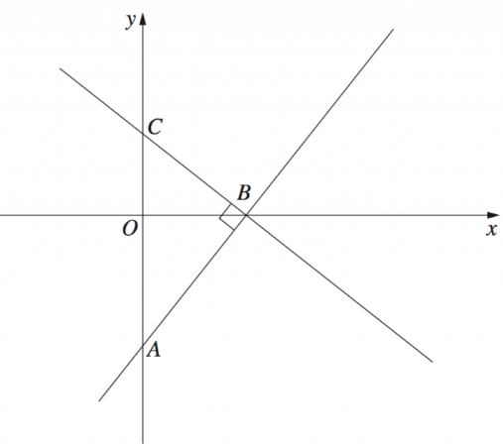
  - Find the equation of line $BC$ in the form $y=mx+c$.

$Gradient of AB: \sqrt{3}$ $Perpendicular gradient: -\frac{1}{\sqrt{3}}$
$$B is x intercept of y = \sqrt{3}x- 3$$
$$0 = \sqrt{3}x- 3$$
$$x = \sqrt{3}$$
$$B = \left(\sqrt{3}, 0\right)$$
$$BC through B with gradient -\frac{1}{\sqrt{3}}: y - 0 = -\frac{1}{\sqrt{3}}\left(x - \sqrt{3}\right)$$
$$y\sqrt{3}= -x + \sqrt{3}$$
$$x + y\sqrt{3}= \sqrt{3}$$
$y=-$ $\frac{1}{\sqrt{3}}$ $x+1$
  - Find the area of triangle $ABC$.
A is y-intercept of AB: x = 0 gives y = -3
C is y-intercept of BC: x = 0 gives y = 1
Base AC = 4 units, height $= \sqrt{3}$ (horizontal distance from $y$-axis to B)
$$Area =\frac{1}{2}\left(4\right)\left(\sqrt{3}\right) = 2\sqrt{3} units²$$
$2\sqrt{3}$ units²

